**Digital online anaesthesia patient informed consent - an overview of the current implementation in Europe**

Claudia Neumann1, Grigorij Schleifer1, Nadine Strassberger-Nerschbach1, Achilles Delis1, Johannes Kamp1, Alexandra Görtzen-Patin1, Dishalen Cudian1, George John2, Andreas Fleischer3, Götz Wietasch4, Mark Coburn1, Ehrenfried Schindler1, Maria Wittmann1*

1. Department of Anaesthesiology and Intensive Care Medicine, University Hospital Bonn, Germany

2. European Society of Anaesthesiology and Intensive Care, Brussels, Belgium

3. KH xy

4. University of Groningen, University Medical Center Groningen, Department

of Anesthesiology, Groningen, the Netherlands

*Corresponding author: PD Dr. med. Maria Wittmann, Email: maria.wittmann@ukbonn.de

**Abstract**[MW4]: Digitalisation in the health system is a topic that is rapidly gaining popularity not only due to the current pandemic. Technical progress, legal frameworks that facilitate remote patient education and timing of informed consent seeking vary across Europe and were thus assessed in this study. As in many areas of daily life, digitalisation is becoming increasingly important in the medical field in the midst of the exponential rise in the use of computers and smartphones.

**Methods:** An online survey entiteled “Digital online Patient Informed Consent for Anaesthesia before Elective Surgery. Recent practice in Europe”, with a total of 27 questions was sent by the European Society of Anaesthesiology and Intensive Care (ESAIC) to their members in 47 European countries. To assess the effect of economy on digitalisation and legal status with regards to anaesthesia consent, data was stratified based on Gross Domestic Product per capita.

**Results:** Out ofa total of 1265 participants 23.1 % of the respondents indicated that it was possible to obtain consent online and 56.7 % via telefone. This observation was more often reported in countries with a high GDP per capita compared to countries where GDP per capita was low. 27.3 % of responses for simple, 18.7 % for complex and 32.2 % for repeated anaesthesia indicated, that remote consent was in accordance with the law and was especially prevalent in countries with high GDP per capita. Concerning the timing of consent, patients were informed at least one day before in 67.1 % for simple and in 85.2 % for complex procedures.

**Conclusion:**  , notably because of the inconsistent legal situation and inhomogenous medical structure across Europe.

**Keywords:** Telemedicine; digital informed consent, legal basis, European practice

**Introduction**

In recent years, there have been more and more efforts to shorten patients' hospital stays and streamline processes [5]. On one hand, these efforts have an economic background on the other hand medical advantages, since shorter hospital stays can for example lead to a reduction in nosocomial infections [6].

The WHO highlights Healthcare-Associated Infections (HCAIs) as a major issue for health providers, patients and public authorities worldwide [1].The ECDC reported that approximately 4.131.000 patients are affected by about 4.544.100 episodes of HCAI every year in Europe, with a mean HCAI prevalence of 7.1% [2]. In this context, HCAIs cause 16 million extra-days of hospital stay and 37 000 attributable deaths (and contribute to an additional 110 000). This amounths to an approximate € 7 billion in associated costs annually [WHO (2011)], with a considerable variability in estimates with a range of 1.2 to 26.4 excess days due to HCAI [3].

Enabling remote contact and communication with patients without physical presence using digital media tools may facilitate reduction of HCAIs. Especially for surgical interventions it may help to keep the pre-operative hospital length of stay as short as possible. Currently however, pre-operative anaesthesiological evaluation is carried out in most hospitals during the pre-operative stay or on an outpatient basis in advance. This practice is backed by the recommendations and guidelines of many medical societies emphasizing a physical contact in the form of Consultation during which a patient is to be legitimately informed on his/ her future anesthetic procedure [8].

Especially, in light of the current COVID-19 pandemic, a reduction of the length of hospital stays is of utmost desirability. Furthermore social distancing is even more important for vulnerable patient groups such as those with multiple comorbidities, immunosuppression, or elderly patients [4], even beyond a pandemic situation.

Thus, the main objective of this study was to determine how widespread the use of telemedicine support in the field of anaesthesiological preoperative consultation is across Europe.

**Methods**

To provide a Europe-wide overview on the current state of technical support and legal framework for telemedical consultation, a cross-sectional study in the form of a survey comprising of a total of 27 questions was sent through the European Society of Anaesthesiology and Intensive Care (ESAIC) to its members in 47 European countries.

The survey was designed as a multiple choice questionnaire with the possibility to add comments or omit questions. Written answers were not analysed for this study and did not contribute to the results presented here. Test runs revealed the questionnaire could be completed in 7-10 minutes. It was possible to resume answering the survey if the session had to be interrupted.

The main focus of our survey was particularly on the general and technical possibility of digital education in the field of anaesthesia and the assessment whether a remote online or telephone anaesthesia consent procedure would comply with the currently prevailing legal framework across different European countries – the participating anaesthetists were asked to judge this according to their own assessment and to the best of their knowledge. We also gathered information on the time frame of the preoperative visit distinguished between low and high risk procedures.

In order to analyse the effect of economic health on our results, a separate subanalysis was performed. To accomplish this task, technical implementation of internet and telephone-based solutions facilitating remote consent process and perception of legal differences were investigated in relation to the gross domestic product per capita (GDP per capita) and this was taken into account during the discussion upon whether significant disparities existed. Quantitative data for GDP per capita was accessed online (<https://data.worldbank.org/indicator/ny.gdp.pcap.cd>) and countries that were represented in our study were assigned into 3 groups namely high, middle and low GDP per capita. The assignment process was performed so that every group had a similar count of countries in every group. A detailed tabulated overview can be found in the supplementary material section (Table S3).

The survey was implemented by using an open source online questionnaire tool “LimeSurvey CE” (Version 5.1, <https://community.limesurvey.org/downloads/>), and was hosted on a secured Linux Debian (Version 10.11) server. The link to the questionnaire was distributed by the ESAIC communication committee (<https://kai-survey.de/limesurvey/733779/>) to 42,433 active members and the survey was conducted over a three-week period (July to August 2021). An ethical approval for this survey was not requested, because data was obtained completely anonymous. The members of the ESAIC did give their consent to take part in regular surveys on the membership homepage.

Absolute numbers and proportions of responses were provided for every question used in this observational survey. Differences in the study population and subanalysis groups were compared using a chi-square test of independence. The nature of the association between the row (gross domestic product per capita) and column (the likelihood to give a certain answer) in contingency tables was interpreted by identifying cells with the highest Pearsons residuals as an estimate of raw residuals standard deviation (r). Cells having the highest Pearson residuals show the direction but also the strength of associative effect between dependent and independent variables. Positive residuals are blue, suggesting a positive association and negative residuals are red, suggesting a negative association. Residuals that exceed 2 in absolute value indicate a lack of fit of the null hypothesis. Significance level was set to *p* ≤ 0.05 and all analyses were performed using the statistical language R (R Core Team, Vienna, Austria, Version 3.6.2). An interactive web application was programmed to provide additional insight into the survey population (<https://kai-survey.shinyapps.io/ESAIC-KAI-survey-2021>). All code for statistical analysis and visualisation can be accessed online (<https://github.com/GrigorijSchleifer/EJA-ESAIC-survey>).

**Results**

The survey “Digital online Patient Informed Consent for Anaesthesia before Elective Surgery. Recent practice in Europe”, conducted by the University Hospital Bonn and ESAIC took place in July 2021, and aimed to capture state-of-the-art anaesthesiological consultation facts complemented by a judgement of online or telephone assessment / informed consent. The survey consisted of 27 questions, collected responses from 47 European countries and was completed by 1265 participants. Overall, data was provided by medical doctors (99 %, n = 920), nurses (0.2 %, n = 2) and physician assistants (0.6 %, n = 6). 56 % (n = 521) of survey participants were male and 43.6 % (n = 406) female, respectively. Consent was obtained predominantly by consultants (78.6%, n = 731) or residents (15.4 %, n = 143) (Table 1). Most answers were contributed by colleagues from Germany (14.2 %, n = 132), Spain (7.8 %, n = 73) and Switzerland (7 %, n = 65) (Table S1).

**Table 1.** Descriptive statistics of the study population stratified by gender.

|  |  |  |  |  |
| --- | --- | --- | --- | --- |
|  |  |  |  |  |
|  | **female** | **male** | **Diverse** | **p** |
| n (%) | 406 (43.6) | 521 (56) | 3 (0.3) |  |
| **Profession (%)** |  |  |  | <0.001 |
| Medical doctor | 402 (99.0) | 516 (99.2) | 2 (66.7) |  |
| Nurse | 0 (0.0) | 1 (0.2) | 1 (33.3) |  |
| Physician assistant | 4 (1.0) | 2 (0.4) | 0 (0.0) |  |
| Other | 0 (0.0) | 1 (0.2) | 0 (0.0) |  |
| **Your expert level (%)** |  |  |  | 0.33 |
| Anaesthesia technician | 4 (1.0) | 6 (1.2) | 0 (0.0) |  |
| Consultant | 303 (74.8) | 426 (81.8) | 2 (66.7) |  |
| Resident | 75 (18.5) | 67 (12.9) | 1 (33.3) |  |
| Special trained nurse | 0 (0.0) | 1 (0.2) | 0 (0.0) |  |
| Other | 23 (5.7) | 21 (4.0) | 0 (0.0) |  |

To assess the availability of digital media that facilitate remote informed consent across Europe, we asked if it was possible to obtain consent via internet or telephone. In 70.2 % (n = 486) of the responses, informed online consent was not possible or it was not uniformly implemented (6.6%, n = 46). However, 23.1 % (n = 160) of respondents stated that consent via internet was already used in clinical routine. Anaesthesia consent via telephone could not be obtained in 37.2 % (n = 257). On the contrary 56.7 % (n = 391) of respondents answered that patient education via telephone was available and 6.1% (n = 42) mentioned varying technical solutions (Figure 1). Based on this observation, consultation via telephone seems to be more frequently used for anaesthesia informed consent.

**Figure 1:** Is it possible to obtain informed consent online via internet or telephone in your routine setting?

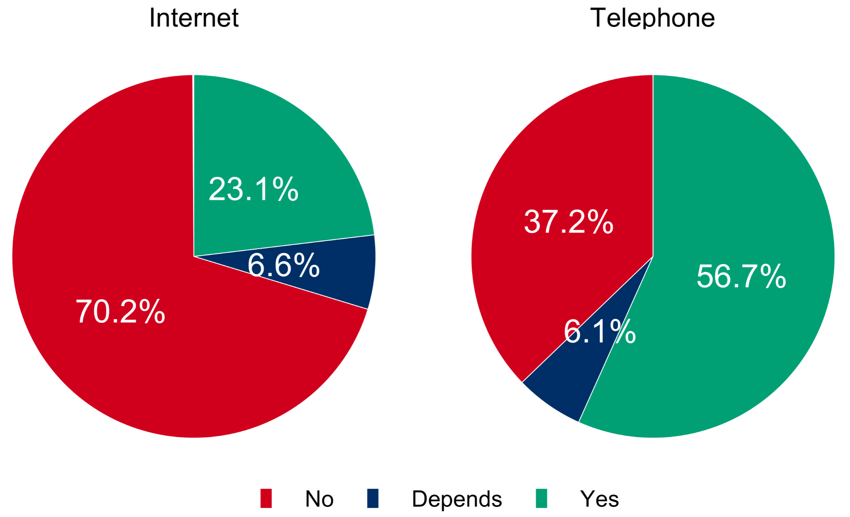

To shed light on a possible association of economic health and usage of internet or telephone-based solution for remote consent, data were stratified based on gross domestic product per capita (GDP per capita). The strength and direction of association between GDP per capita and the usage of internet or telephone was estimated by calculating Pearson’s residuals as described in the statistics section. While in countries with a low GDP per capita, internet usage seemed to be less common (Pearson’s residual = -1.18), countries having higher gross domestic product were positively associated with online remote consent (Pearson’s residual = 1.5) per capita (Figure 2, A). Interestingly, remote consent process for anaesthesia via telephone was even more associative with increased GDP per capita. Although in countries with low GDP per capita telephone was not commonly used for anaesthesia consent (Pearson’s residual = -2.57) its implementation was strongly associated with increased economic status (Pearson’s residual = 4.56) (Figure 2, B).

**Figure 2:** Is it possible to obtain informed consent online via internet or telephone in your routine setting? (stratified by high, middle and low Gross Domestic Product per capita)

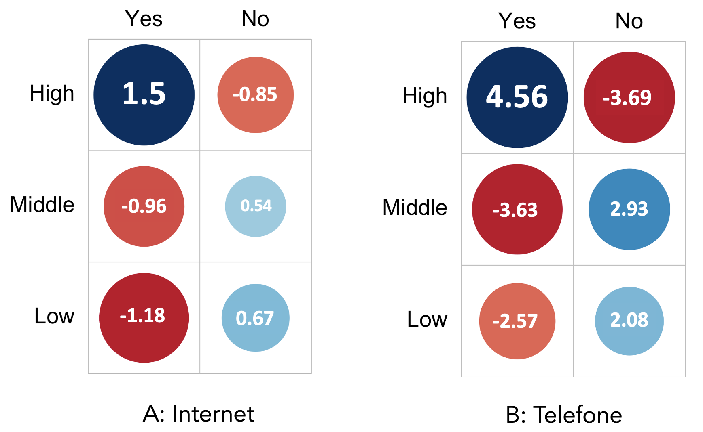

Based on our previously published subanalysis on paediatric population, we could show that legal regulations vary considerably across Europe. Here, we assessed if online/telephone consent was in accordance with legal requirements for the adult patient population. For simple procedures, 37.2 % (n = 298) of respondents stated that remote informed consent was not in accordance with legal regulations in their country and was legally sound in 27.3 % (n = 219). For complex procedures, remote consent, to the knowledge of the participants with regards to the legal framework in course, was not possible due to legal requirements in 42.5 % (n = 341) and only in 18.7 % (n = 150) it was according to the participants’ understanding of their judiciary setup compliant with the law. In 35.5 % (n = 285) for simple and 38.8% (n = 311) for complex procedures of the respondents were unsure about legal regulation with respect to online/telephone informed consent (Figure 3).

**Figure 3:** Is a remote informed consent in accordance with the legal requirements for simple or complex procedures and would it be allowed for repeated anaesthesia?

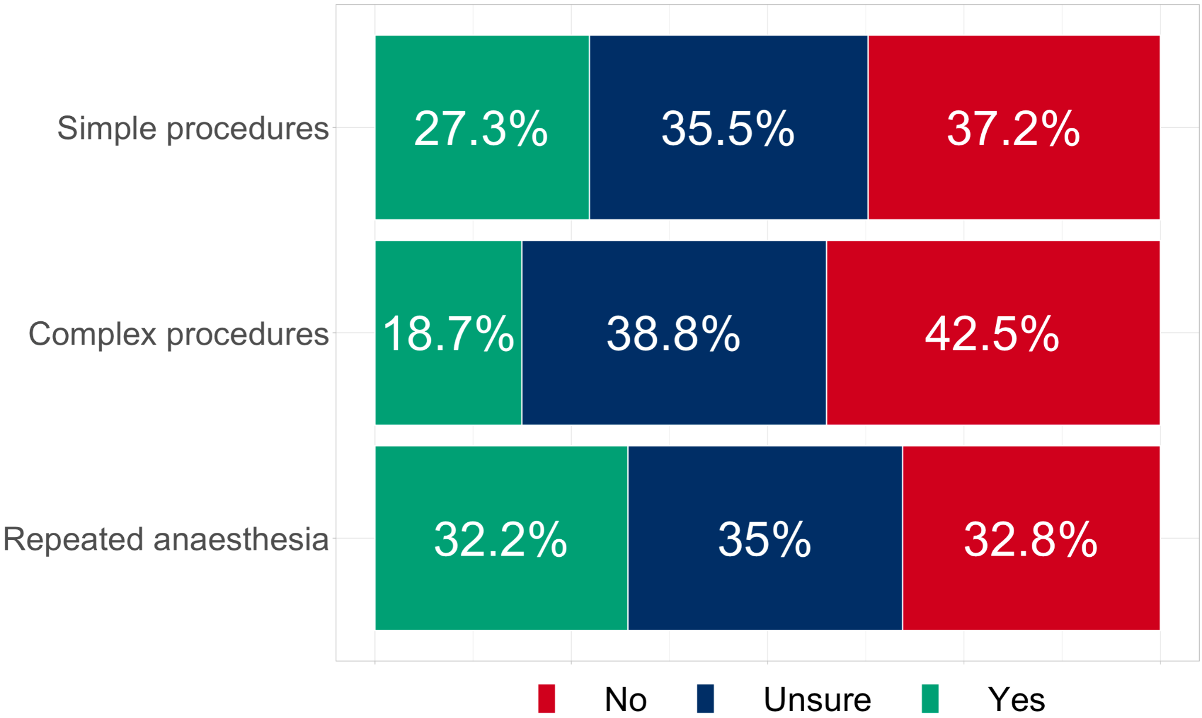

To estimate the effect of economic status and digitalisation on legal framework with respect to remote consent for simple, complex and repeated anaesthesia, data was stratified based on gross domestic product per capita (GDP per capita) as described in the methods section. Our data showed a high positive association of high GDP per capita with remote informed consent being in accordance with legal requirements for simple, complex and repeated anaesthesia (Pearson’s residuals: 5.37 (simple), 4.33 (complex), 5.35 (repeated)). In countries with low GDP per capita on the conrary, online remote consent was more often stated to be not in accordance with legal requirements for simple, complex and repeated anaesthesia (Pearson’s residuals: -4.17 (simple), -2.98 (complex), -4.21 (repeated)) (Figure 4). These observations suggest that with improving economic status legal regulations tend to favor remote consent process while while in countries with weaker economies remote anaesthesia process are discouraged legally.

**Figure 4:** Is remote informed consent in accordance with the legal requirements for simple or complex procedures and would it be allowed for repeated anaesthesia? (stratified by Gross Domestic Product per capita)

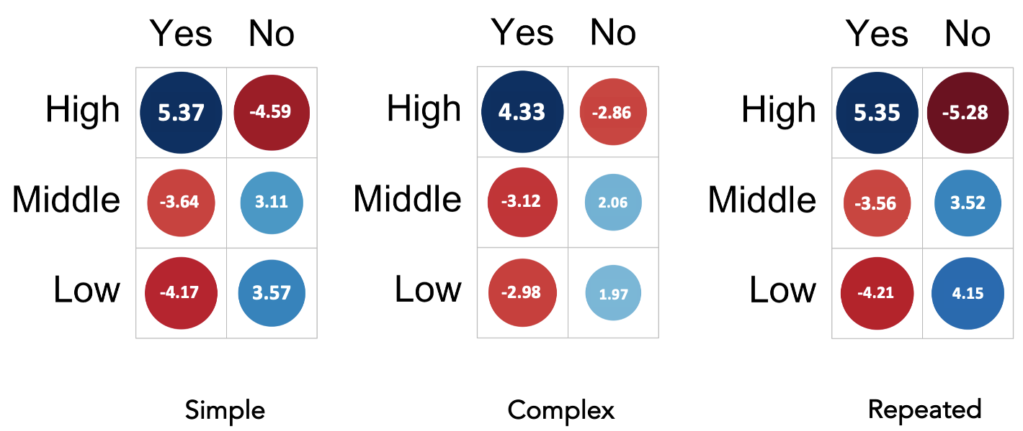

It has been shown that shorter hospital stays can save costs and lead to a reduction in nosocomial infections. We therefore investigated if procedure severity had an effect on the timing as to when informed consent was performed. For simple procedures, informed consent was obtained in 12.9 % (n = 103) two days or more and in 54.2 % (n = 433) 24 hours or less before surgery. In 32.9 % (n = 263) consent was obtained on the same day of surgery. In comparison, for complex procedures, consent was obtained in 33.6 % (n = 269) two days or more and 51.6 % (n = 413) 24 hours and less before the surgical intervention. On the day of surgery, content was acquired only in 14.8 % (n = 118). Here we observed that patients who needed an extended procedure were more likely to stay overnight compared to patients with simple procedures indicating higher costs and increased chance of exposure to nosocomial infections.

**Figure 3:** When do you need to obtain Informed consent for elective surgery based on legal requirements for simple and complex procedures?

**​​**

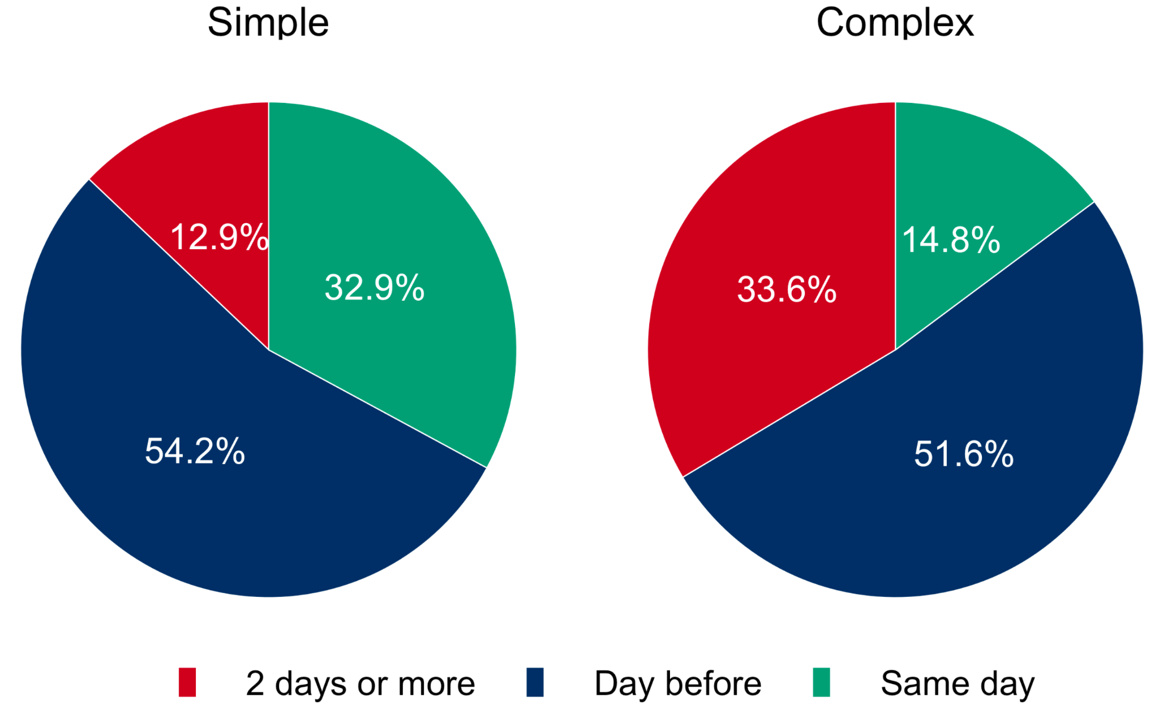

**Discussion**

In the main result, our study showed how different the implementation of telemedical support in the context of an anaesthesia consultation is across Europe and that there is widespread uncertainty about the legal framework. Also, interesting differences could be found when looking at the background of the different gross domestic products in relation to the answers.

The use of telemedical support in the field of medicine has been available for years, but has so far only been used with restraint [9]. The objective advantages, such as cost savings, reduction of waiting times for patients, avoidance of unnecessary travel and thus more timely care, especially in rural areas, are obvious. In addition, since the beginning of the Covid-19 pandemic, there has been an increasing desire for social distancing, especially for patients with pre-existing conditions who are more at risk from the virus.

In contrast to this, the legal situation in many countries of the European Union is such that purely remote information for medical interventions is at least questionable. While this may be legally compliant in simple cases, in the event of a lawsuit the doctor must prove that the patient was informed just as well and comprehensively as in a face-to-face conversation despite the exclusive use of telemedicine.Quelle?

The requirement for written consent also still poses problems in practice, as an electronic signature cannot be implemented everywhere technically and has not yet become routine in the health sector, in contrast to its increasingly widespread use in other areas of daily life.

Thus, the results of this Europe-wide survey shed light on some interesting aspects of the points raised.

Regarding the possibility of obtaining anaesthesiological consent online or by telephone, most respondents stated that this was not the case, with the use of the internet being mentioned even less frequently as an alternative possibility. If one includes the results of the sub-analysis regarding the gross domestic product, it becomes apparent that in countries with a higher GDP, the use of telemedical support tends to be performed more often and is more widespread considered legal, at least for repeated anaesthesia and simpler procedures. This may reflect the better technical conditions in these countries.

The overall assessment of the legal situation shows a clear picture in this survey. Only 19 to 32 % percent believed that telemedical information is legal, whereas 33 to 43% answered that it is not in accordance with the legal requirements. As already mentioned, a very large proportion of respondents are unclear about the legal regulation (35 - 39 %), regardless of the severity of the procedure or repeat anaesthesia.

*Legal basis of informed consent*

The reason for face to face or telemedical education is to achieve an informed consent with the patient for the planned medical procedure. But informed consent is not a requirement for anaesthesia or medical interventions itself. It is based on the right to self-determination enshrined in the constitutions, in Germany, for example, in Articles 1 I 2 II Grundgesetz. (Constitution). Information by telephone before routine procedures is possible, as is information on the day of the operation before outpatient procedures. (H. Bürkle, Patientenaufklärung in der Anästhesiologie 2018)

In some EU countries, telemedicine is now regulated by law: I e in Sweden, the law of Freedom-of-Choice (Lag om Valfrihetssystem, LOV, 2019) forms the legal basis for telemedicine. Telemedicine doctors can establish their services anywhere as long as they fulfil the Swedish regulation for health care providers [10].

In the Netherlands, patients' rights are governed by the Treatment Contract Act (Wet geneeskundige behandelingsovereenkomst, WGBO) which is part of Book 7 (Special Contracts) of the Dutch Civil Code (NBW). The WGBO obliges the physician to inform the patient in a clear manner ("op duidelijke wijz"), in writing if desired, about the examinations and treatments envisaged and treatments (Art. 7:448 para. 1 BW) [11]. Here, anaesthesiological education without physical contact dominates the clinical routine.

Health care is the responsibility of individual member states and has no uniform Europe-wide regulation. Specific legal regulations for the use and handling of telemedicine are lacking in many countries, and harmonisation across the EU is often described as unfeasible, also because of data protection problems [9]. As of the time of writing of this article, the European Union is taking a first but giant step towards the unification of data exchange systems through the creation of the European Data Health Space, first brought to light on the 03.05.2022 which is geared to empower the growth and expansion of telemedicine through the emanation of a true European network for data exchange thus facilitating the integration of practices such as digital online informed consent.

Looking at the time frame in most cases, the patient is informed at least one day before a procedure; this applies to simple and complex procedures (67.1 % vs. 85.2 %). Here, an alternative would be to provide information via the Internet as a video consultation, for example, and to personally call in only those patients for whom additional examinations are really necessary or cannot be performed by the general practitioner. This could save costs and possibly save the patient a long journey as well as may reduce the risk of nosocomial infections.

The increasing proportion of responses to see the patient at least 2 days before complex procedures is not surprising in that there may be a need for further diagnostics or general preparation.

When it comes to the question of who is responsible for anaesthesia education, the consultants predominate in the overall comparison and only in exceptional cases are anaesthesia technicians or nurses involved. However, it is interesting that this also occurs and seems to be legally permitted in some countries.

Even though the potential advantages of using telemedicine were positively assessed in the survey, especially with regard to less stress and reduced waiting times, the wish for the future, however, is still to carry out face-to-face patient information. This also did not differ between the countries with high, medium or low GDP, and might have been expected in the second year of the pandemic (status of the survey 2021). The assessment in this regard may also be due to the fact that the legitimacy of pure remote information of the patient is so often doubted.

The statement of 35 - 38.8s % percent of the respondents that they are unsure about the legal framework conditions or even fear that it is illegal especially catches the eye.

Of course, , fears are also expressed regarding trust, contact and the lack of preoperative observation of the patient [7]. However, if a clear legal framework could be created for the physician that legitimised telemedical information, many patient groups could benefit from this. In the age of increasing digitalization, it should be legally possible to bring online medical consultations on an equal footing with face-to-face consultations. In cases of doubt, of course, the attending physician decides in consultation with the patient which procedure is most appropriate. In addition, personal contact should always be offered to the patient upon request, especially since many elderly patients may also lack access to technical media. In conclusion, legal pitfalls should not be an unnecessary obstacle here in times when communication via computers or smartphones has become the norm in many other areas of everyday life.

**Strength and Limitations**

This questionnaire was sent out to 42,433 active ESAIC members in 47 countries. The response rate was just 2.2%, with 930 responses and was not equally distributed across all countries, but nevertheless, anaesthesiologists from 47 different nations were obtained.

Furthermore, although the questionnaire was designed with maximum care by experienced clinical and research anaesthesiologists, response bias may have arisen. As the questionnaire was only sent out once by ESAIC, there was no possibility of pre-testing in order to evaluate a possible bias effect of primer questions. Thus, the validity of the results found could be limited because of induced question-order effects. However, the survey was performed completely anonymously without any human contact and so socially desirable responses and interviewer bias should not be a concern.

**Conclusion**

Our survey was able to shed light on how differently the use of telemedicine support in the field of anaesthesia is handled in Europe, even though many professional societies have been recommending it for years (Quellen).

The restrictive attitude may also be due to the fact that there is no clear legislation in this regard and the anaesthetist is on thin ice legally when it comes to the mere use of telemedicine media. A Europe-wide harmonisation would therefore be desirable, even if it will be difficult to implement this equally for all countries in the near future. The Covid 19 pandemic may have given an impetus here to use appropriate procedures where this is technically possible and advantageous for the patient.

It remains a promising outlook for the future, from which the health care system as a whole and many patients will be able to benefit.

**Acknowledgements**

We thank the ESAIC for support and for distribution of the questionnaire.

We would also like to thank Johannes Kamp, who has a degree in law, for researching the legislation in the respective countries and Alexandra Görtzen-Patin for reviewing the manuscript as a native speaker.

**References**

**List of Supplemental Digital Content**

[1] World Health Organization (2011) Report on the burden of endemic health care-associated infection worldwide. World Health Organization, Geneva.

[2] European Centre for Disease Prevention and Control (2008) Annual epidemiological report on communicable diseases in Europe 2008 : report on the state of communicable diseases in the EU and EEA/EFTA countries. European Centre for Disease Prevention and Control, SE

[3] Manoukian S et al. (2018) Estimating excess length of stay due to healthcare-associated infections: a systematic review and meta-analysis of statistical methodology. Journal of Hospital Infection 100:222–235

[4] Bhaskar S, Bradley S, Chattu VK, et al. Telemedicine as the New Outpatient Clinic Gone Digital: Position Paper From the Pandemic Health System REsilience PROGRAM (REPROGRAM) International Consortium (Part 2). *Front Public Health*. 2020;8:410. Published 2020 Sep 7. doi:10.3389/fpubh.2020.00410

[5] Tsai HW, Huang SW, Hung YL, Hsu YS, Huang CC. Use of the Smart Lean Method to Conduct High-Quality Integrated Perioperative Management Prior to Hospitalization. Int J Environ Res Public Health. 2021 Dec 20;18(24):13391. doi: 10.3390/ijerph182413391. PMID: 34949000; PMCID: PMC8708543.

[6] Jia H, Li L, Li W, et al. Impact of Healthcare-Associated Infections on Length of Stay: A Study in 68 Hospitals in China. *Biomed Res Int*. 2019;2019:2590563. Published 2019 Apr 18. doi:10.1155/2019/2590563

[7] Neumann, C et al. “Digital Online Anaesthesia Patient Informed Consent before Elective Diagnostic Procedures or Surgery: Recent Practice in Children-An Exploratory ESAIC Survey (2021).” *Journal of clinical medicine* vol. 11,3 502. 19 Jan. 2022, doi:10.3390/jcm11030502

[8] Patient Information and Informed Consent before and after Medical Intervention

Dtsch Arztebl 2007; 104(9): A-576

Parzeller, M; Wenk, M; Zedler, B; Rothschild, M

[9] Raposo VL. Telemedicine: The legal framework (or the lack of it) in Europe. GMS Health Technol Assess. 2016 Aug 16;12:Doc03. doi: 10.3205/hta000126. PMID: 27579146; PMCID: PMC4987488

[10] Blix, Mårten; Jeansson, Johanna (2018) : Telemedicine and the welfare state: The Swedish experience, IFN Working Paper, No. 1238, Research Institute of Industrial Economics (IFN), Stockholm

[11]Ivo Giesen, Arzthaftung in den Niederlanden (Ivo Giesen, Hoogleraar Privaatrecht aan het Molengraaff Instituut van de Universiteit Utrecht en UCALL (Utrecht Centre for Accountability and Liability Law)<http://ivogiesen.com/publicaties/> abgerufen März 2022

[12] Ellen Gielen, Judith Kok, Digital health apps and telemedicine in the Netherlands, 10.1, published 14.dec. 2020;<https://cms.law/en/int/expert-guides/cms-expert-guide-to-digital-health-apps-and-telemedicine/netherlands>

[13] *Kania in: Schlegel/Voelzke, jurisPK-SGB V, 4. Aufl., § 365 SGB V (Stand: 10.11.2021) Randnummer 18;*

[14] *Bundestag-printed matter 19/3438, page 70: Assuming that oral communication means simultaneity, but not in the same place.*

**Supplementary Material**

**Table S1:** Number of responses

|  |  |  |  |
| --- | --- | --- | --- |
| **Country of employment? n (%)** |  |  |  |
| Albania | 3 (0.3) | Liechtenstein | 1 (0.1) |
| Austria | 32 (3.4) | Lithuania | 8 (0.9) |
| Belarus | 2 (0.2) | Luxembourg | 4 (0.4) |
| Belgium | 27 (2.9) | Malta | 6 (0.6) |
| Bosnia and Herzegovina | 5 (0.5) | Moldova | 3 (0.3) |
| Bulgaria | 8 (0.9) | Monaco | 1 (0.1) |
| Croatia | 26 (2.8) | Netherlands | 50 (5.4) |
| Cyprus | 4 (0.4) | Macedonia | 3 (0.3) |
| Czechia | 10 (1.1) | Norway | 8 (0.9) |
| Denmark | 11 (1.2) | Poland | 19 (2.0) |
| Estonia | 4 (0.4) | Portugal | 56 (6.0) |
| Finland | 12 (1.3) | Romania | 31 (3.3) |
| France | 24 (2.6) | Russia | 12 (1.3) |
| Georgia | 2 (0.2) | Serbia | 14 (1.5) |
| Germany | 132 (14.2) | Slovakia | 8 (0.9) |
| Greece | 45 (4.8) | Slovenia | 14 (1.5) |
| Hungary | 8 (0.9) | Spain | 73 (7.8) |
| Iceland | 1 (0.1) | Sweden | 43 (4.6) |
| Ireland | 18 (1.9) | Switzerland | 65 (7.0) |
| Israel | 6 (0.6) | Turkey | 23 (2.5) |
| Italy | 40 (4.3) | Ukraine | 7 (0.8) |
| Kazakhstan | 2 (0.2) | United Kingdom (UK) | 44 (4.7) |
| Kosovo | 3 (0.3) | Uzbekistan | 2 (0.2) |
| Latvia | 10 (1.1) |  |  |

**Table S2:** …

|  |  |  |
| --- | --- | --- |
| **Is it possible to obtain informed consent online via *internet* in your routine setting? p = 0.101** | | |
|  | **Yes** | **No** |
| **High GDP** | 89 (75) [1.5] | 222 (235) [-0.85] |
| **Middle GDP** | 49 (56) [-0.96] | 181 (174) [0.54] |
| **Low GDP** | 19 (25) [-1.18] | 83 (77) [0.67] |
| **Is it possible to obtain informed consent online via *telephone* in your routine setting? p = <0.001** | | |
|  | **Yes** | **No** |
| **High GDP** | 175 (124) [4.56] | 139 (190) [-3.69] |
| **Middle GDP** | 56 (91) [-3.63] | 173 (138) [2.93] |
| **Low GDP** | 24 (40) [-2.57] | 78 (61) [2.08] |
| **Is an online telephone informed consent for elective surgery in accordance with the p = <0.001**  **legal requirements in your country (*simple*)** | | |
|  | **Yes** | **No** |
| **High GDP** | 164 (108) [5.37] | 92 (148) [-4.59] |
| **Middle GDP** | 45 (77) [-3.64] | 137 (105) [3.11] |
| **Low GDP** | 9 (32) [-4.17] | 69 (45) [3.57] |
| **Is an online telephone informed consent for elective surgery in accordance with the p = <0.001**  **legal requirements in your country (*complex*)** | | |
|  | **Yes** | **No** |
| **High GDP** | 110 (73) [4.33] | 130 (167) [-2.86] |
| **Middle GDP** | 30 (53) [-3.12] | 143 (120) [2.06] |
| **Low GDP** | 9 (23) [-2.98] | 68 (54) [1.97] |
| **Thinking of repeated anaesthesia, would an online telephone informed consent p = <0.001**  **then be allowed for elective surgery due to legal requirements?** | | |
|  | **Yes** | **No** |
| **High GDP** | 187 (127) [5.35] | 70 (130) [-5.28] |
| **Middle GDP** | 54 (87) [-3.56] | 123 (90) [3.52] |
| **Low GDP** | 14 (40) [-4.21] | 69 (42) [4.15] |

**Table S3:**

|  |  |  |
| --- | --- | --- |
| Country | GDP per capita (billions) | Group |
| Liechtenstein | 175,813.90 | High |
| Luxembourg | 116,014.60 | High |
| Switzerland | 87,097.00 | High |
| Ireland | 85,267.80 | High |
| Norway | 67,329.70 | High |
| Denmark | 61,063.30 | High |
| Iceland | 59,270.20 | High |
| Netherlands | 52,397.10 | High |
| Sweden | 52,274.40 | High |
| Finland | 48,745.00 | High |
| Austria | 48,586.80 | High |
| Germany | 46,208.40 | High |
| Belgium | 45,159.30 | High |
| Israel | 44,168.90 | High |
| United Kingdom (UK) | 41,059.20 | High |
| France | 39,030.40 | Middle |
| Italy | 31,714.20 | Middle |
| Malta | 27,884.60 | Middle |
| Cyprus | 27,527.80 | Middle |
| Spain | 27,063.20 | Middle |
| Slovenia | 25,517.30 | Middle |
| Estonia | 23,027.00 | Middle |
| Czechia | 22,931.30 | Middle |
| Portugal | 22,176.30 | Middle |
| Lithuania | 20,233.60 | Middle |
| Slovakia | 19,266.50 | Middle |
| Latvia | 17,726.30 | Middle |
| Greece | 17,622.50 | Middle |
| Hungary | 15,980.70 | Middle |
| Poland | 15,721.00 | Middle |
| Croatia | 14,134.20 | Low |
| Romania | 12,896.10 | Low |
| Russia | 10,126.70 | Low |
| Bulgaria | 10,079.20 | Low |
| Kazakhstan | 9,122.20 | Low |
| Turkey | 8,536.40 | Low |
| Serbia | 7,720.50 | Low |
| Montenegro | 7,677.20 | Low |
| Belarus | 6,424.20 | Low |
| Bosnia and Herzegovina | 6,079.70 | Low |
| North Macedonia | 5,917.30 | Low |
| Albania | 5,246.30 | Low |
| Moldova | 4,547.10 | Low |
| Kosovo | 4,346.60 | Low |
| Ukraine | 3,724.90 | Low |
| Uzbekistan | 1,750.70 | Low |